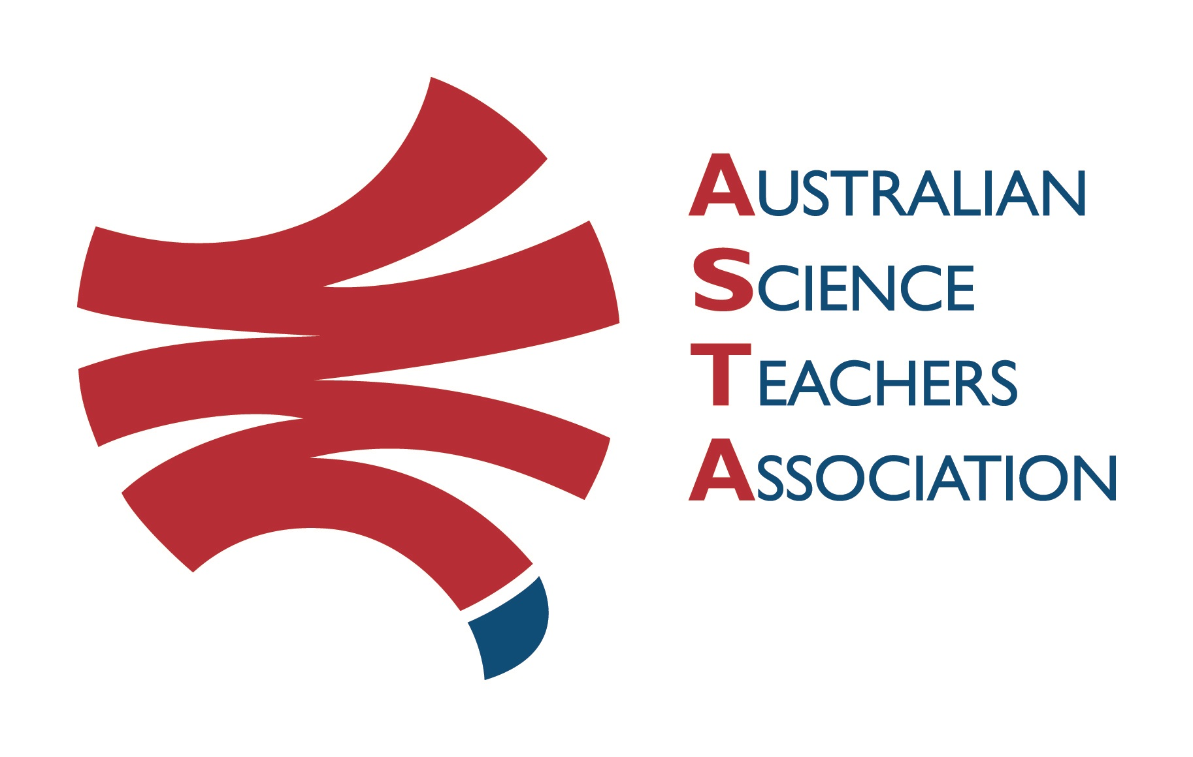
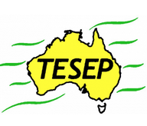

Professional Development Workshop Series in Earth and Environmental Science
TESEP PRESENTS: AFTER SCHOOL PROFESSIONAL DEVELOPMENT (PD)

Mon 3 April 2023, 3:30pm-6pm 2-PD Rocks (TESEP Rock Kit Teaching Pack) &
Fossils, Evolution & Extinctions (Aust fossil changes through time, big extinctions, integrated plate tectonics/climate/volcanic events)
Tue 16 May 4pm-6pm Fieldtrip, Rock Stories, Northern Grampians, (stories of the local rocks, guide through worksheets), meet at Halls Gap (details tbc)
School: Holy Trinity Lutheran College, 25 Trinity Dve, Horsham Vic
Meeting Room: Agora meeting space - Senior School building, Reception
Date: Mon 03 April 2023 PD workshop, Tue 16 May Fieldtrip, Facilitator: Paige Moore, Horsham
The RocksExpo experience includes–
1. Incursions – classroom lessons with students and teachers.
2. PD workshops – After-school professional development workshops for teachers (1- to 2-PD sessions @ $25 per attendee for visiting teachers, FREE to host-school teachers).
3. ASTA Certificate of attendance – A certificate of hours and workshop outcomes will be issued.
4. FREE rock kit – Host to receive a FREE rock kit and Plate Tectonics poster.
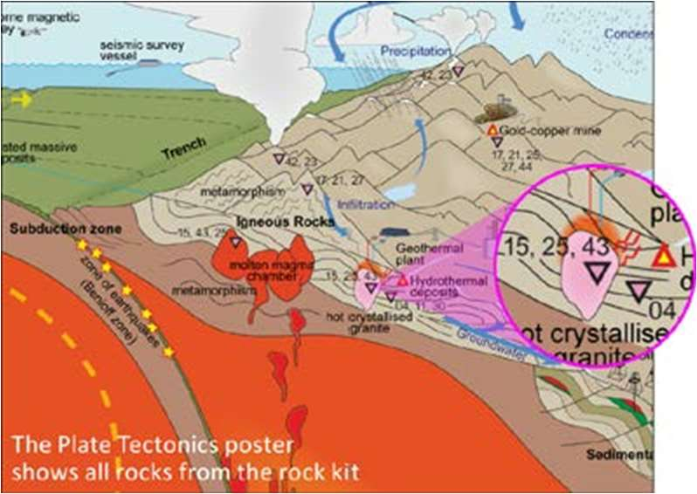
5. Introductory RocksExpo feature How to Use the Rock Kit and Teaching Pack (e.g. how to relate rock kit rocks to rock stories, 3D rendered samples, virtual thin sections and virtual outcrops).
Teacher Earth Science
Education Programme
6. Subsequent RocksExpo topics can be chosen from TESEP’s “The Challenging Earth” series
Presenters: Rob Kirk has expertise in sedimentary basin and palaeontology, with many rock and fossil stories and samples to share. Dr Stephen Carey (ex-Federation Univ, Ballarat) will lead the fieldtrip. He has many years of studying the geology of this region and in teaching earth science.

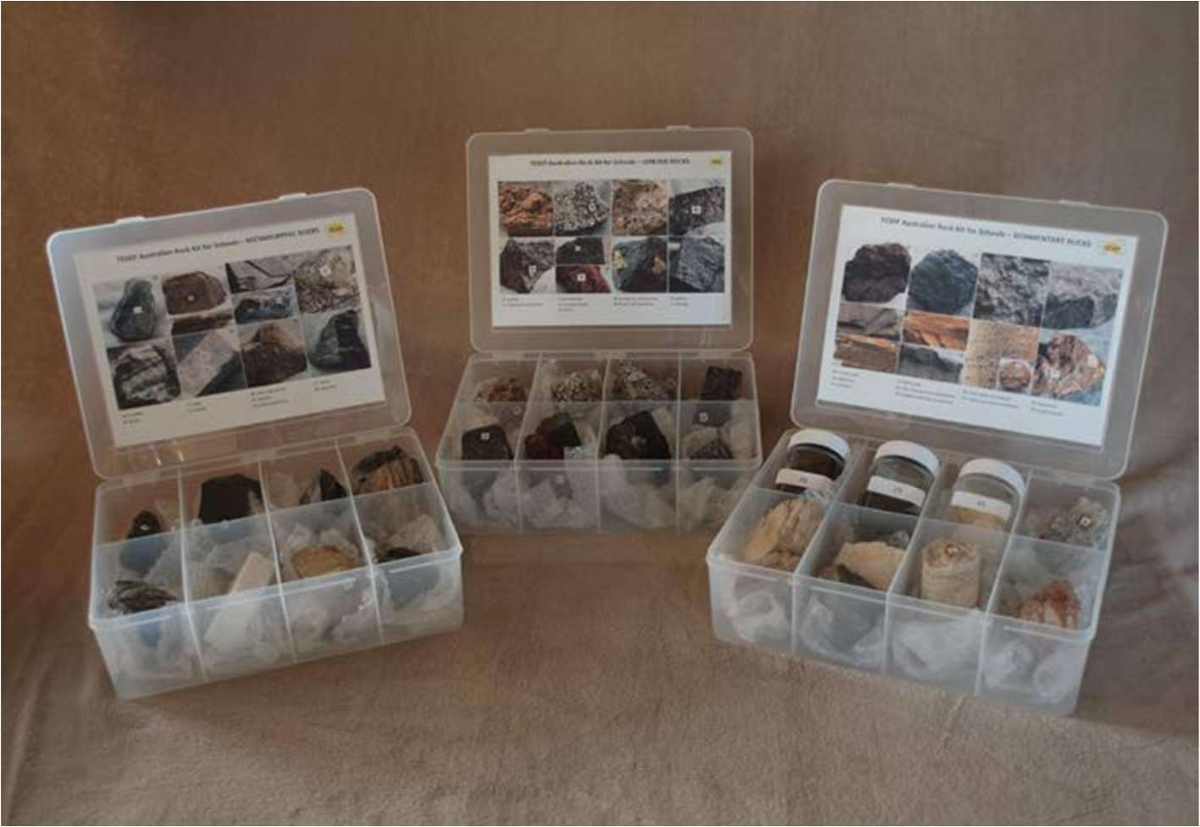

tesep.org.au

asta.edu.au
Booking form
Name:
School:
Teaching Area:
Phone (School):
Email:
Home postal address:
Special Dietary and other requirements:

Professional Development Workshop Series in Earth and Environmental Science
Email or fax form to ASTA (office manager – Michelle Lollback). Send the non-refundable* registration fee (includes GST) to Australian Science Teachers Association (ABN 87 902 882 824).
Payment can be made by direct bank transfer or cheque/money order. Please include your name and workshop details with payment (e.g. TESEP PD9 NSW July 20 J. Citizen).
*The fee is transferable to another PD workshop or for another teacher to substitute
Email: officemanager@asta.edu.au | Address: TESEP - ASTA  PO Box 334 Deakin West ACT 2600
Account Details: Australian Science Teachers Association (ASTA) BSB: 082 902 Account No: 556 705 700

Please tick here if you require an invoice ☐ and provide address if different from the one above:

A certificate will be issued by ASTA which states the number of PD attendance hours. For registration inquiries contact registration@tesep.org.au
Please Note: Issuing of a certificate is conditional on workshop payment.

Registration fee: Free for teachers working at the host school and other sponsored schools. $25 per attendee for each other (non-sponsored) school.

please print clearly
Workshop: Monday - 2-PD Rocks (Rock Kit teaching pack) & Fossils, Evolution & Extinctions & Tuesday - fieldtrip (with worksheets) to Northern Grampians | Date: Mon 3 April & Tue 16 May 2023
Venue: Holy Trinity Lutheran College, Horsham PDs, Fieldtrip N Grampians | State: Vic

