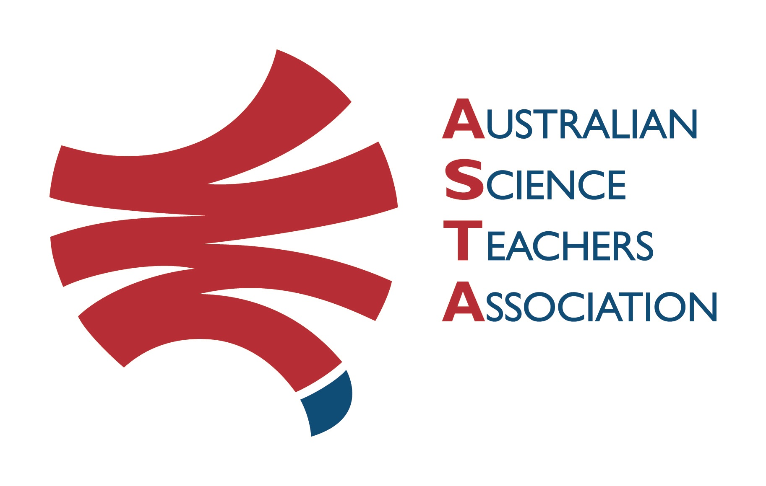
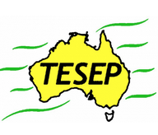

Professional Development Workshop Series in Earth and Environmental Science
TESEP PRESENTS: AFTER SCHOOL PROFESSIONAL DEVELOPMENT (PD)

Thur 24 Aug Rocks (Rock Kit Teaching Pack) & Intro - Volcanoes/Faults of NSW
Fri 25 Aug Rocks/Rock Cycle Game, Our Place in Space, Aust Volcanoes (hands-on exercises)
Sat 26 Aug 1:15-5:30pm Volcanoes near & far, Critical Minerals (& Energy Transition), Wet Rocks (groundwater/artesian basins – related to surface water)
GeoTrail Volcanoes guided walk (with earth & bio-scientists) Fri & Sat 8:30am-12pm, all events, please register p2, note which GeoTrail session
School: Coonabarabran HS, Newell Hwy, Coonabarabran, NSW
Meeting Room: Library Meeting Room
Date: Thur 24 – Sat 26 August 2023, all weekday PDs 3:30-6pm, networking dinner Fri evening
School Facilitator: Maleisah Eshman
The RocksExpo experience includes–
1. Incursions – classroom lessons with students and teachers.
2. PD workshops – After-school professional development workshops for teachers (1- to 2-PD sessions @ $25 per attendee for visiting teachers, FREE to host-school teachers).
3. Certificate of attendance – A certificate of hours and workshop outcomes will be issued.
4. FREE rock kit – Host to receive a FREE rock kit and Plate Tectonics poster.
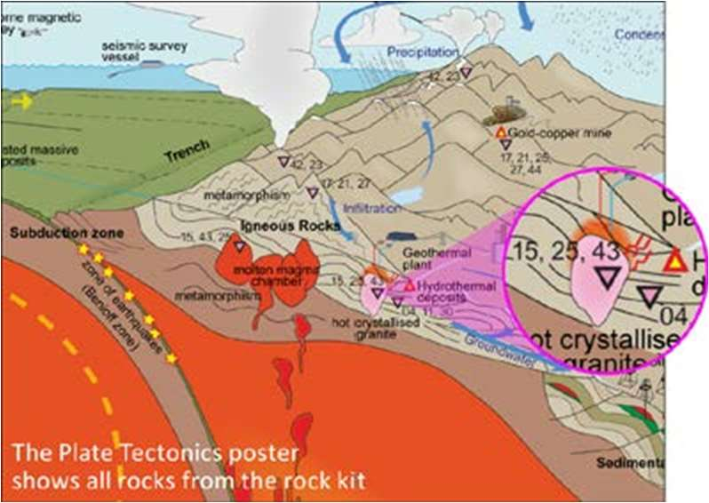
5. Introductory RocksExpo feature How to Use the Rock Kit and Teaching Pack (e.g. how to relate rock kit rocks to rock stories, 3D rendered samples, virtual thin sections and virtual outcrops).
Teacher Earth Science
Education Programme
Presenters: Phil Gilmore is a keen ore & volcanoes geologist and Katarina David is a hydro-geologist. Their work in several states gives them many rock stories and samples to share.
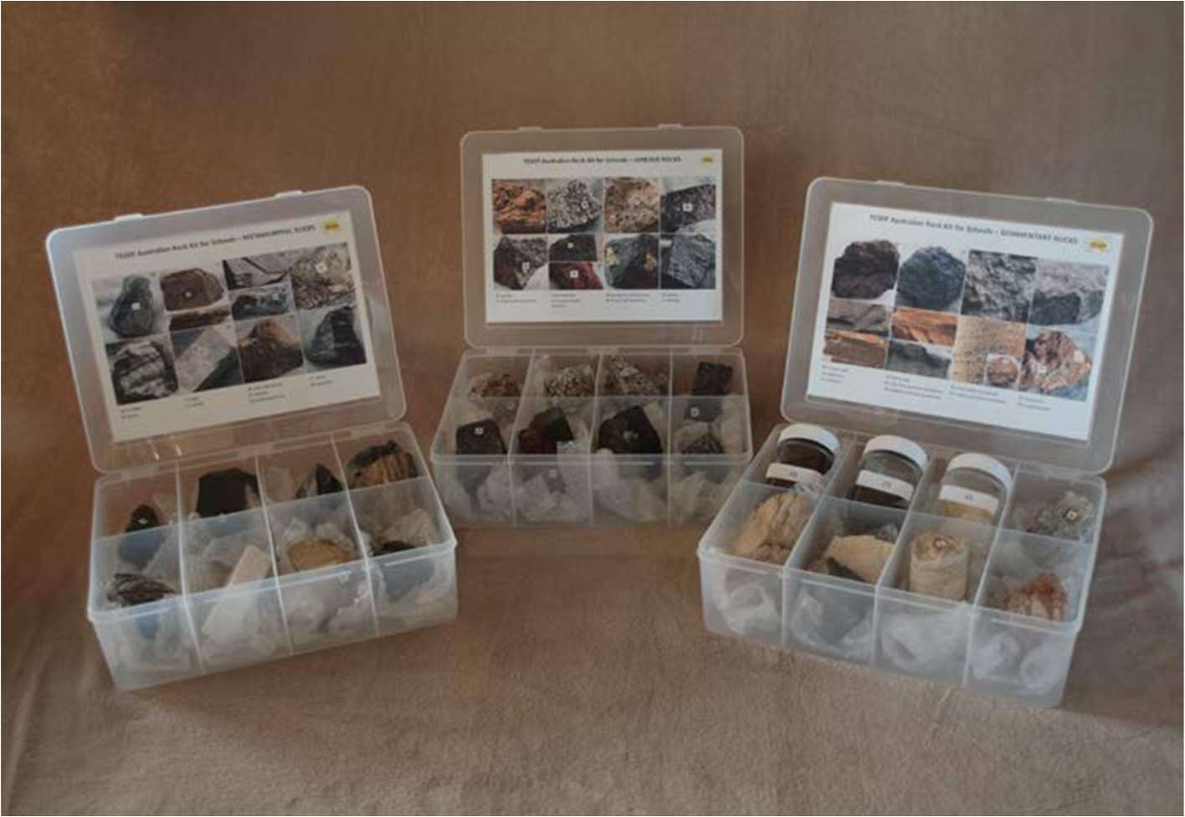

tesep.org.au

asta.edu.au
Booking form
Name:
School:
Teaching Area:
Phone (School):
Email:
Home postal address:
Special Dietary and other requirements:

Professional Development Workshop Series in Earth and Environmental Science
Email or fax form to ASTA (office manager – Michelle Lollback). Send the non-refundable* registration fee (includes GST) to Australian Science Teachers Association (ABN 87 902 882 824).
Payment can be made by direct bank transfer or cheque/money order. Please include your name and workshop details with payment (e.g. TESEP PD9 NSW July 20 J. Citizen).
*The fee is transferable to another PD workshop or for another teacher to substitute
Email: officemanager@asta.edu.au | Address: TESEP - ASTA  PO Box 334 Deakin West ACT 2600
Account Details: Australian Science Teachers Association (ASTA) BSB: 082 902 Account No: 556 705 700

Please tick here if you require an invoice ☐ and provide address if different from the one above:

A certificate will be issued by ASTA which states the number of PD attendance hours. For registration inquiries contact registration@tesep.org.au
Please Note: Issuing of a certificate is conditional on workshop payment (if non-host school) & getting teacher email address & filled-in teacher feedback form.

Registration fee: Free for teachers working at the host school and other sponsored schools. $25 per attendee for each other (non-sponsored) school.

please print clearly
Workshop: PD Thu Rks & Intro Volc, Fri Rks/Space/NSW Volc Story, Sat- Volcanoes near/far, Critical Minerals (Energy), Wet Rocks (groundwater) | Date: 24-26 Aug 2023
Venue: Coonabarabran High School | State: NSW

