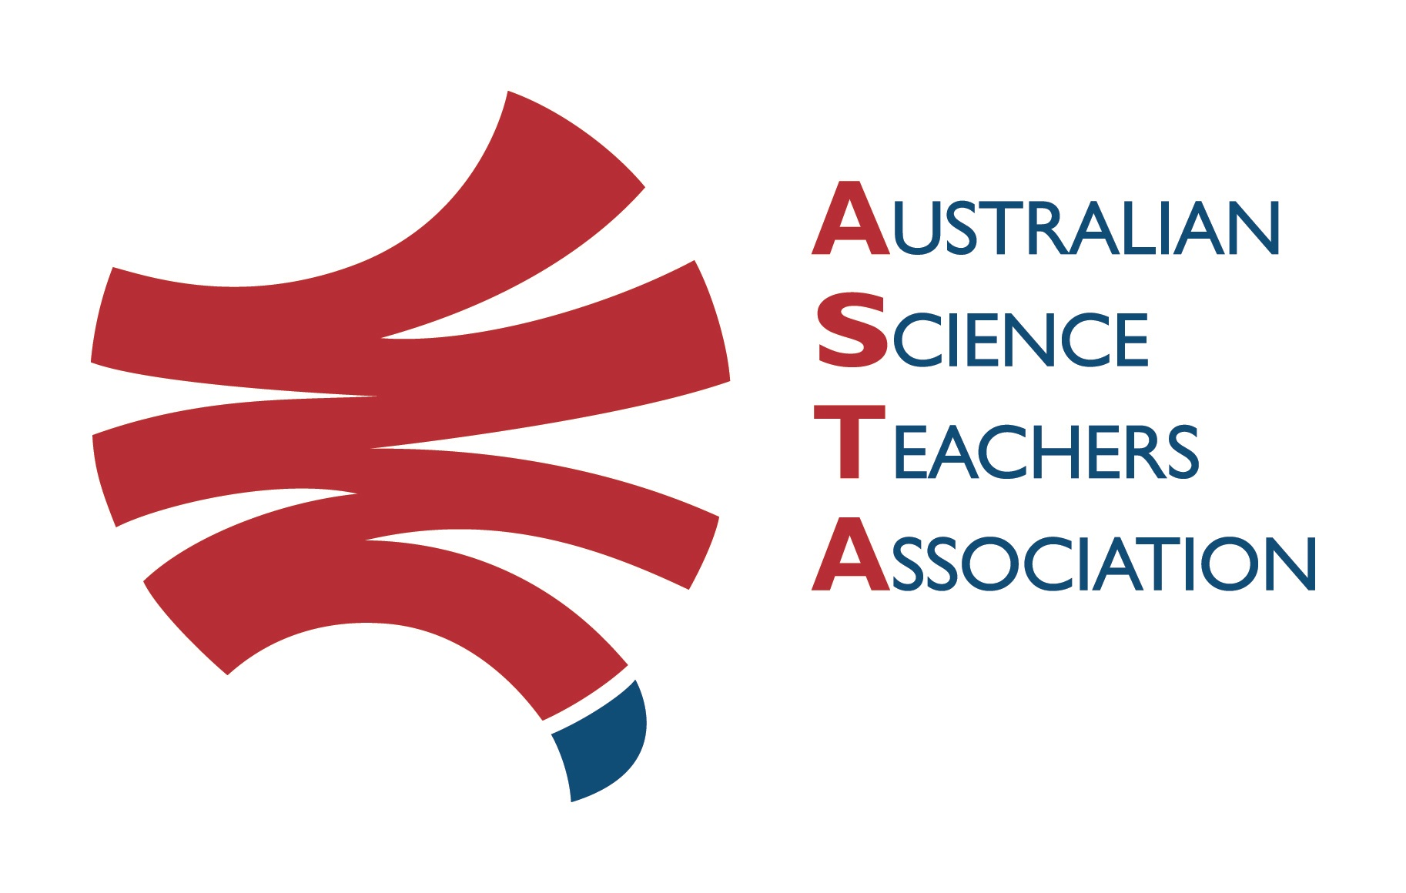
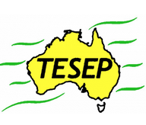

Professional Development Workshop Series in Earth and Environmental Science
TESEP PRESENTS: AFTER SCHOOL PROFESSIONAL DEVELOPMENT (PD)

Fri 31 March 3:30pm-6pm 2-PD workshops – teachers & community welcome to attend FREE
Rocks - How to use the Rock Kit teaching resources &
Plate Tectonics - integrated plate tectonics/climate/volcanic changes through Earth history – related to Pyramid Hill, Vic & eastern Australia geology
School: Pyramid Hill College, 97 Kelly St, Pyramid Hill, Vic
Meeting Room: go to front office to sign in & be directed to meeting room
Date: Thursday 30 March 2023, PD workshop Facilitator: Elizabeth Fox
The RocksExpo experience includes–
1. Incursions – classroom lessons with students and teachers.
2. PD workshops – After-school professional development workshops for teachers (1- to 2-PD sessions @ $25 per attendee for visiting teachers, FREE to host-school teachers).
3. ASTA Certificate of attendance – A certificate of hours and workshop outcomes will be issued.
4. FREE rock kit – Host to receive a FREE rock kit and Plate Tectonics poster.
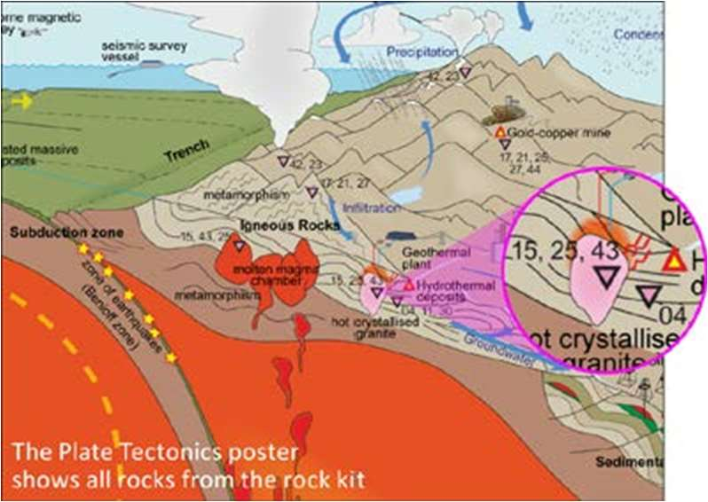
5. Introductory RocksExpo feature How to Use the Rock Kit and Teaching Pack (e.g. how to relate rock kit rocks to rock stories, 3D rendered samples, virtual thin sections and virtual outcrops).
Teacher Earth Science
Education Programme
6. Subsequent RocksExpo topics can be chosen from TESEP’s “The Challenging Earth” series

Presenter: Rod Boucher is a keen ore geologist, who has worked in industry around Australia.
His work in several states gives him many rock stories and samples to share.
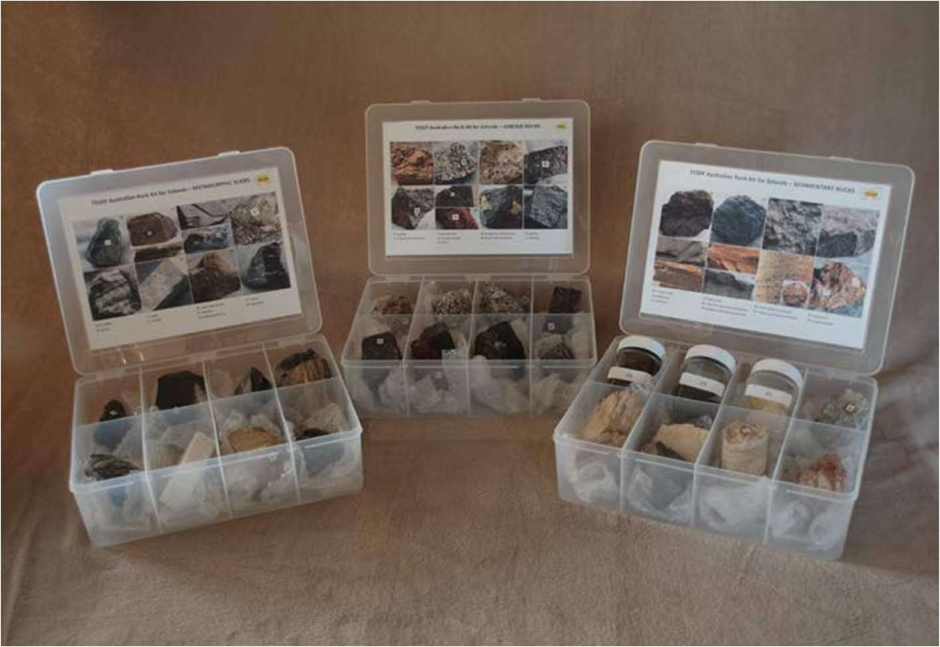
29 Palm-sized rocks in the TESEP Australian Rock Kit for Schools & close-up of TESEP Plate Tectonics poster

tesep.org.au

asta.edu.au
Booking form
Name:
School:
Teaching Area:
Phone (School):
Email:
Home postal address:
Special Dietary and other requirements:

Professional Development Workshop Series in Earth and Environmental Science
Email or fax form to ASTA (office manager – Michelle Lollback). Send the non-refundable* registration fee (includes GST) to Australian Science Teachers Association (ABN 87 902 882 824).
Payment can be made by direct bank transfer or cheque/money order. Please include your name and workshop details with payment (e.g. TESEP PD9 NSW July 20 J. Citizen).
*The fee is transferable to another PD workshop or for another teacher to substitute
Email: officemanager@asta.edu.au | Address: TESEP - ASTA  PO Box 334 Deakin West ACT 2600
Account Details: Australian Science Teachers Association (ASTA) BSB: 082 902 Account No: 556 705 700

Please tick here if you require an invoice ☐ and provide address if different from the one above:

A certificate will be issued by ASTA which states the number of PD attendance hours. For registration inquiries contact registration@tesep.org.au
Please Note: Issuing of a certificate is conditional on workshop payment.

Registration fee: Free for teachers from host school and other sponsored schools. Free to local community. Please register – for catering (light supper).

please print clearly
Workshop: Monday - 2-PD Rocks (Rock Kit teaching pack) & Plate Tectonics | Date: Fri 31 March 2023
Venue: Pyramid Hill College, Pyramid Hill | State: Vic

